

EC Upgrade BKK Use Case

Project Name
BKK 11.2 Project Energy Components

Use-Case Name
BKK_UC36 Maintain Stream Reference Values
Origination Date
27-Dec-2017

Revision History

Revision | Date | Description | Prepared  by | Checked  by | Approved by
1.0 | 27-Dec-2017 | Draft of Use Case “Maintain Stream Reference Values” | Wirasak C.
1.1 | 27-Mar-2018 | Updated as per EC 11.2 | Tieto
2 | 2-July-2020 | Thailand ECsasS | Wirasak C.

Table of Contents

1. Use Case Information 4
2. Primary Flow: BKK_UC36 Maintain Stream Reference Values 4
3. Alternatives 6
4. Exceptions 6
4.1 Exception Flow: Required Fields Not Populated 6
5. Additional Clarifying Information 6
5.1 Additional Variations 6
5.2 Business Rules: 6

Use Case Information

Use Case Number and Name | BKK_UC36-Maintain Well Reference Values
Brief Description | M&M Users will manually change version of stream in order to record meter properties might be from time to time change on e.g.  Meter Set (Master FC Meter or Backup Meter, Orifice Size, and Tube Diameter etc.
Related Use Cases | BKK_UC35 Setup Stream
EC Roles  (list EC roles that may execute Use Case) | - Roles can be able to execute this use case are M&M CTEP Technologist, M&M COTL Technologist roles.
EC Business Functions
Prerequisites | - User is logged In  - User has permission to access the Maintain Stream Reference Values screen in EC  - Stream has been created.
Approver

Note: the toolbar on EC11.2 has changed. Refer to the image below for different buttons

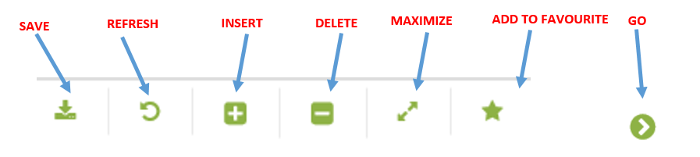

Primary Flow: BKK_UC36 Maintain Stream Reference Values

Trigger: M&M technologist of CTEP or COTL set-up the stream wanted to update some specific constant values that apply to the stream. These constant values can be applied to various calculations and used for reporting. Use this process to enter reference values for a new stream or to enter a new version of reference values for a stream that should be applied after a specific date.

Step | Actor Action | System Response | Notes
1. | Navigate to the Stream Reference Values screen  Administration Assets Stream Objects Stream Reference Values | In the Navigator, the date and hierarchy are retained from the Stream Set List screen.
2. | In the Navigator, use the Stream drop-down menu to select the stream that was just created and click Go…  Operation Hierarchy  - Production Unit  - Product Sub Unit  - Area  - Sub Area  - Facility Class 2  Facility Class 1 (N/A) | New headings appear in the Data Window and a message “no records found…”
3. | Mouse hover to the Insert icon on the toolbar and click on the New Version/New Object | Daytime field appears in the Data Window
4. | Enter the “Effective Date” in Daytime | Date is displayed in Start Date | Format is yyyy-mm-dd  This is also the stream’s start date.
5. | Click the Save icon in the Tool Bar | List of all the constants that can be set appears in the Data Window
6. | Locate the constant that needs to be set and enter the value | Common meter reference values for MCBU include:  - Meter Set  - Meter Factor  - Orifice Size[in]  - Tube Diameter[in]  - Inlet Separator  - Flash Factor[Sm3/Sm3]  Meter Set dropdown list options include :  - Master FC Meter  - Backup FC Meter  Inlet Separator dropdown list options include :  - Inlet Separator 1  - Inlet Separator 2  - Commingled
7. | Click the Save icon in the Tool Bar | Entry is saved.
 | END OF USE CASE

Alternatives
none

Exceptions

Exception Flow: Required Fields Not Populated

Step | Actor Action | System Response | Ref
E7.1 | User does not enter an EC required field | Pop-up window: “Required fields are empty. Please enter data for these fields:  “Field Name on Row #.”

Additional Clarifying Information

Additional Variations
Not all wells will have well reference values.

Business Rules:
Business Rule | Data Elements | Description
BR.1 | Daytime | The start date can be in the past or future. (except for in a locked month)  Formatted as yyyy-mm-dd.

